TEMPLATE FOR THE ONE-PAGES-ABSTRACT

A. Abcde^{1,*}, C. Fghaij¹, K. Mnopqr²
1: Dept. of Xxxxxxx Eeeeee, The University of Tabcd, Country
2: Dept. of Yyyyyyy Fffffff, The University of Wabcd, Country
* Correspondent author: email@adress.xxx.yz

Keywords: signal processing, micro beam, forced vibration, heat transfer
ABSTRACT
The purpose of this 1-Pages abstract is to provide the conference participant with a clear idea about your work, what kind of techniques has been used and the core results obtained. Therefore, the Highlights are the most important part of the abstract.
If the abstract does not contain formulas and figures you can paste it in the window which appears during the submission process. We, however, advise you to upload a supplementary file in MS WORD format in order to facilitate the publishing of the abstracts.
(1) Page size format is A4 (210 mm x 297 mm). Do not exceed one page! Write 4 to 6 keywords and use only one e-mail address for the correspondent author.
(2) Use the template supplied and do not make your own Word File in any other format. The body text is with 10pt Times New Roman – Regular and a Line Spacing of “At least” 16.5pt. The title is 11 pt Times New Roman, bold type capital letters


Fig. 1 An example of a figure within a Lock Anchored Textbox that occupies the entire page width.
(4) To avoid deviating from the Word template, use the “Paste Special …” option in the Edit menu and choose “Unformatted Text”.
(5) Since this is still a One-Pages Abstract, if you would like to include equations and figures, please, balance the word count with the size of figures.
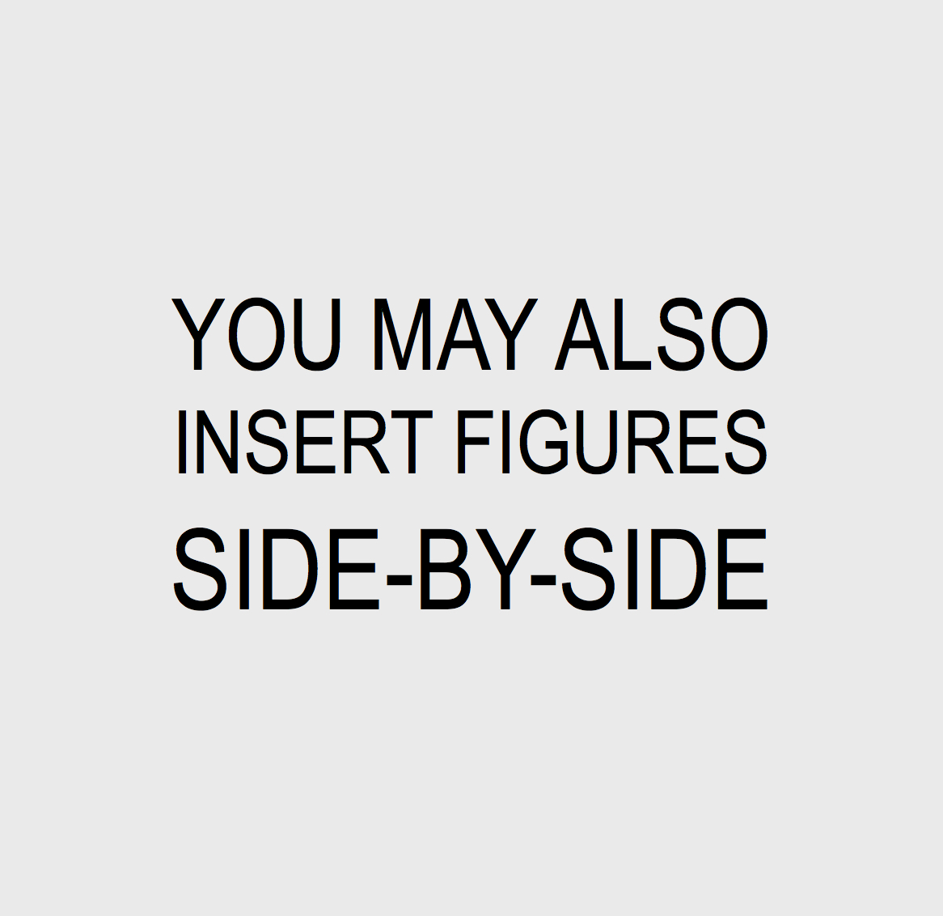
Fig. 2 This is an example of more than one figure side-by-side. Caption is set in 9pt TNR– Regular
Save your file in MS Word format. Upload the abstract up to 15 February 2017 at the site:
http://www.icoev2017.org/ocs/index.php/icoev/ICOEV2017/login
Please avoid sending the abstract by e-mail and do it only if absolutely necessary.
If you have any questions, send an email to icoev@icoev2017.org.

